[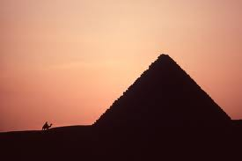](http://www.google.com/imgres?imgurl=http://www.toreigeland.com/egyptweb/content/bin/images/large/W0381_Sunset_Menkaure_pyramid.jpg&imgrefurl=http://www.toreigeland.com/egyptweb/content/W0381_Sunset_Menkaure_pyramid_large.html&h=585&w=875&sz=56&tbnid=cNZgceQ8aI2dFM:&tbnh=93&tbnw=139&zoom=1&usg=__Zy5FBYlfiO6h2L_0wKa9YElfaIo=&docid=qRO9SI5cMHmrfM&hl=en&sa=X&ei=Jh7vUNylH8S30QHY7oGAAg&sqi=2&ved=0CEgQ9QEwBw&dur=1182)

22

MINUTES

Do Circuit Once

Rest 1 Minute

REPEAT!

**POWER PYRAMID**

1. **FOREARM PLANK JACKS**
2. **MOUNTAIN CLIMBERS**
3. **BURPEES**
4. **ALTERNATING CURTSY LUNGE**
5. **PUSH UPS**
6. **RUSSIAN TWISTS**
7. **PUSHUPS**
8. **ALTERNATING CURTSY LUNGE**
9. **BURPEES**
10. **MOUNTAIN CLIMBERS**
11. **FOREARM PLANK JACKS**